Bangladesh House Building Finance Corporation
Public Relations Unit, Head Office, 22, Purana Paltan, Dhaka Phone No. 9560574, Email: pru.bhbfc@gmail.com

Press Release

BHBFC Observes International Mother Language Day
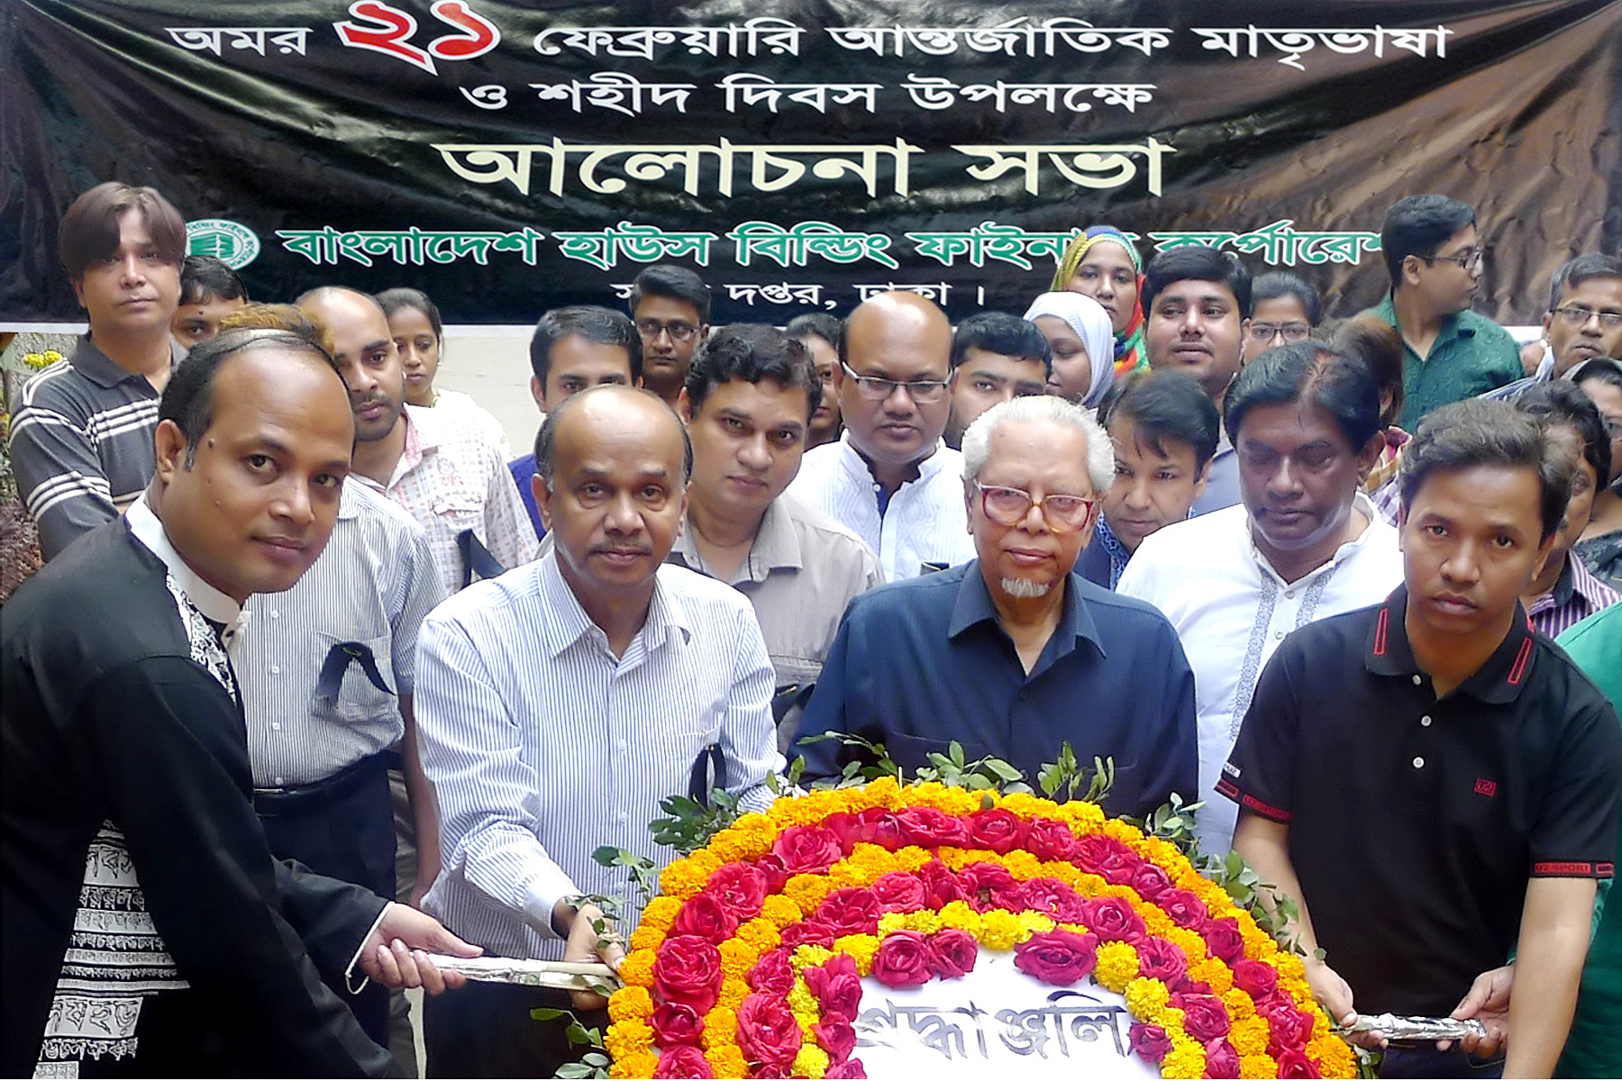
Bangladesh House Building Finance Corporation (BHBFC) observed the International Mother Language and National Martyrs Day on 21st February 2016 with due solemnity by laying wreath consecutively on the Central Shaheed Minar and the Shaheed Minar on the head office premises. Shaikh Aminuddin Ahmed, Chairman of the Board of Directors and Omar Farooque, Managing Director, along with the high officials, Bangabandhu Parishad, Bangamata parishad, Employees Union and employees of the corporation paid homage to the martyrs. A discussion session was also held on this day highlighting the significance of the day.

C:\Users\All User\Desktop\Press\E. 21 February 2016 Press.doc

